Session 19
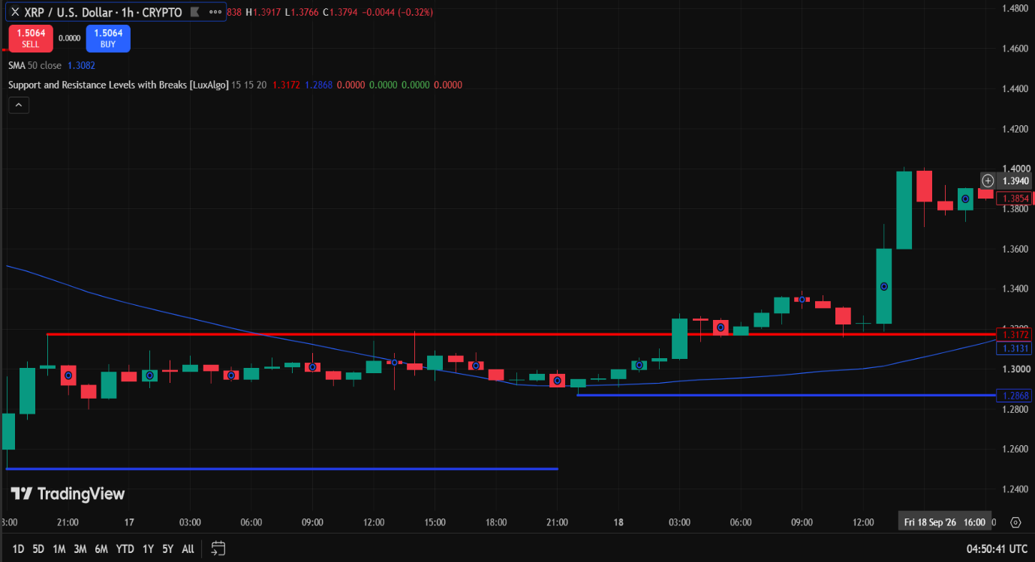

Trend-Based Trading Analysis Report | Details
Asset | XRP / U.S. Dollar
Timeframe | 1h
Prevailing Trend | Uptrend
Position of Price Relation to 50 SMA | Above 50 SMA
Market Structure | Higher highs and higher lows
Proposed Trade Position | BUY / LONG
Is the Trade Aligned with the trend? | Yes
Technical Observations | Price is trading above the 50 SMA (1.3082) with strong bullish momentum breaking previous resistance levels.
Reason for Trading Decision | The strong upward movement and positioning above the 50 SMA indicate continuation of the bullish trend.
Entry Executed | Yes
Key Learning | Following momentum and aligning trades with the 50 SMA in a confirmed uptrend yields favorable setups.

Session 20
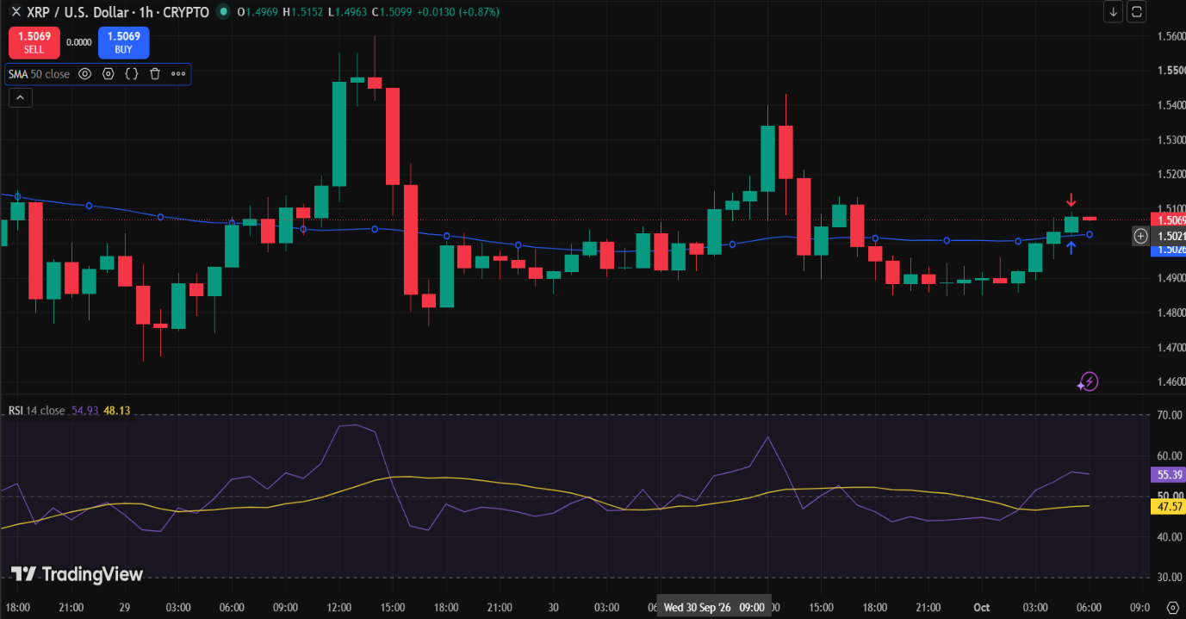
Field | Response
Asset | XRPUSD
Timeframe | 1 Hour
Price Relative to 50 SMA | Above the 50 SMA (price 1.5099, SMA 1.5021)
RSI Value | 55.39
RSI Condition | Above 50 (bullish momentum)
Proposed Trade Position | Buy / Long
Do the Indicators Support the Trade? | Yes. Price is above the 50 SMA and RSI is above 50, both confirming bullish momentum.
Technical Observations | • Price crossed above the 50 SMA (1.5021) and is trading around 1.5099.  • RSI (14) is at 55.39, showing bullish momentum above the 50 mark.  • A blue buy signal arrow is plotted near 1.5026.  • The 50 SMA line is flattening and turning upward, providing dynamic support.
Reason for Trading Decision | Both price action and RSI align for a bullish setup. Price holds above the 50 SMA supported by a buy indicator arrow, while RSI > 50 confirms momentum.
Entry Executed? | No
Key Learning | • Confluence between price position relative to the 50 SMA and RSI > 50 provides stronger trade signals.  • Always wait for the candle close above key moving averages to confirm support before entry.

Session 21
Field | Response
Asset | XRPUSD
Timeframe | 1 Hour (1H)
Prevailing Trend | Downtrend
Market Structure | Lower Highs & Lower Lows (LH & LL)
Support & Resistance Identified? | Yes (Support ~1.50, Resistance ~1.5540)
Price Relative to 50 SMA | Below the 50 SMA
RSI Condition | Below 50 (Bearish Momentum, RSI ~37.41)
Proposed Trade Position | Observe Only
Do All Technical Factors Support the Proposed Trade? | No
Technical Observations | • Price is below the 50 SMA (1.5540), showing short-term bearish pressure.  • RSI has dropped sharply to 37.41, confirming bearish momentum.  • The market structure previously showed higher highs up to ~1.65, but recent candles closed below the 50 SMA, testing support near 1.50–1.53.
Reason for Trading Decision | Although the 50 SMA and RSI suggest bearish conditions, the broader trend shows a pullback rather than a clear structural trend change. Not all factors fully align for a short entry, so the safest decision is to continue observing.
Entry Executed? | No
Key Learning | A complete combined strategy requires alignment across all five factors: trend, market structure, support/resistance, 50 SMA, and RSI. When factors conflict, observing without executing a trade protects against false breakouts.

